Cairo University  
Faculty of Computers and Artificial Intelligence



**CS251**

**Software Engineering I**

Project Name

Software Design Specifications

Version X.X

Team Names and Emails

Month & Year

Contents

Team 3

Document Purpose and Audience 3

System Models 4

I. Class Diagram(s) 4

II. Class Descriptions 5

III. Sequence diagrams 6

Class - Sequence Usage Table 9

IV. State Diagram 10

Tools 10

Ownership Report 11

# 

# Team

|  |  |  |  |
| --- | --- | --- | --- |
| **ID** | **Name** | **Email** | **Mobile** |
| 20190664 | Aya Allah Abed Mahmoud | ayaallah.abed.20@gmail.com | 01124579293 |
| 20190352 | Omer Khaled Mohamed Mohamed | omerkhaledmohamedmohamed123@gmail.com | 01228703875 |
| 20190299 | Abdelrahman Mohamed Saad Abdu | bodyeg123@gmail.com | 01145817461 |

# Document Purpose and Audience

* **This document contains class diagram and its description and contains sequence diagrams and its usage tables.**
* **This document describes the GOFO software system and how it works, who will use it and how.**
* **The target audience: project manager, developers and may be customers.**

# System Models

## I. Class Diagram(s)

## II. Class Descriptions

| **Class ID** | **Class Name** | **Description & Responsibility** |
| --- | --- | --- |
| 1 | user | Defines the specifications of the users of the program in terms of name, id, password , email , phone , location , counter ,  It has two functions: creating profiles for playground owners or opening their current profile |
| 2 | player | He inherits the qualities of a class user with the two characteristics he has and makes a reservation for the stadium or can cancel the reservation and make a favorite team for him that can see all the current players |
| 3 | Playground owner | He inherits the qualities of class user with the addition of three characteristics of his own and rejects or accepts a reservation request for one of his stadiums as much as he adds stadiums if they are identical to the standards and can see all the other playground owner |
| 4 | E-wallet | You have a variable called balance that saves the amount of money owed to each customer in it and can be paid through it to book stadiums we will transfer money between customers and allow to add more money in it or offer the money that exists currently |
| 5 | playground | It is a class that has the specifications of each playground that the owner adds. consists of several properties like : name , location , size , avahours ,price per hour , cancel period , id , pid. |
| 6 | Administrator | consists of several properties like : name , password , email , phone ,player , playground , owner arraylist , id .  He has the right to clear or stop any playground if he has received many complaints from her or deleted player or playground owner |

## III. Sequence diagrams

Registration sequence diagram

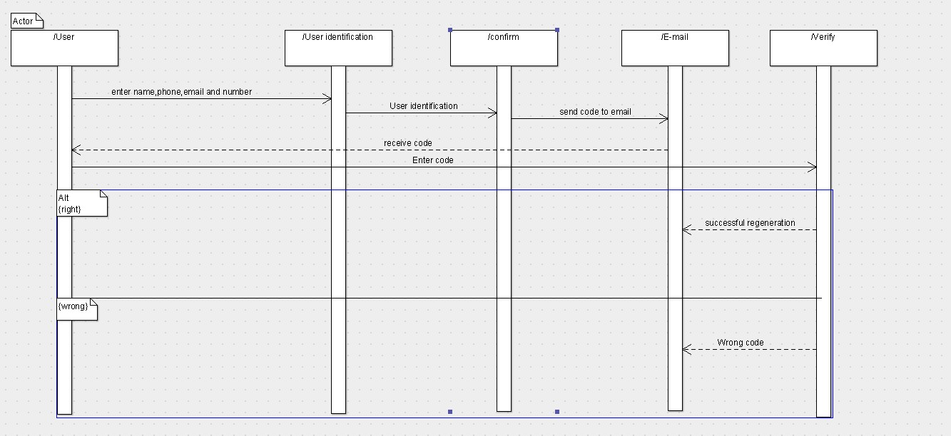

Registration playground sequence diagram

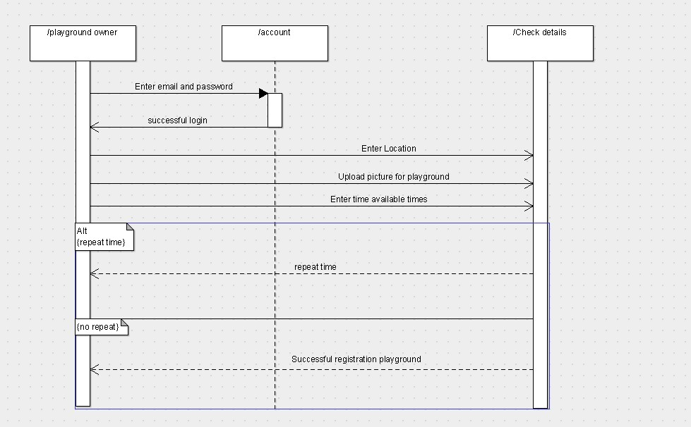

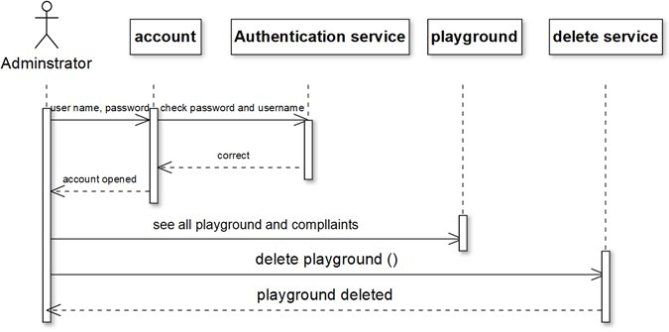Delete playground sequence diagram

Book playground sequence diagram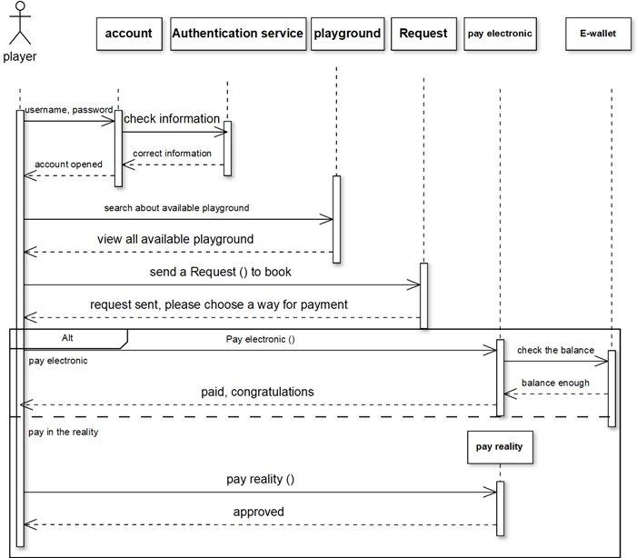

### Class - Sequence Usage Table

| **Sequence Diagram** | **Classes Used** | **All Methods Used** |
| --- | --- | --- |
| 1. Registration | Class user | Methods registering  Methods sign up |
| 1. Registration playground | Class playground owner  Class playground | Methods add  Methods playground |
| 1. Delete playground | Class Administrator  Class playground | Delete method |
| 1. Book playground | Class player  Class playground  Class E-wallet | Search available playground method  Request method  Payment method |

## IV. State Diagram

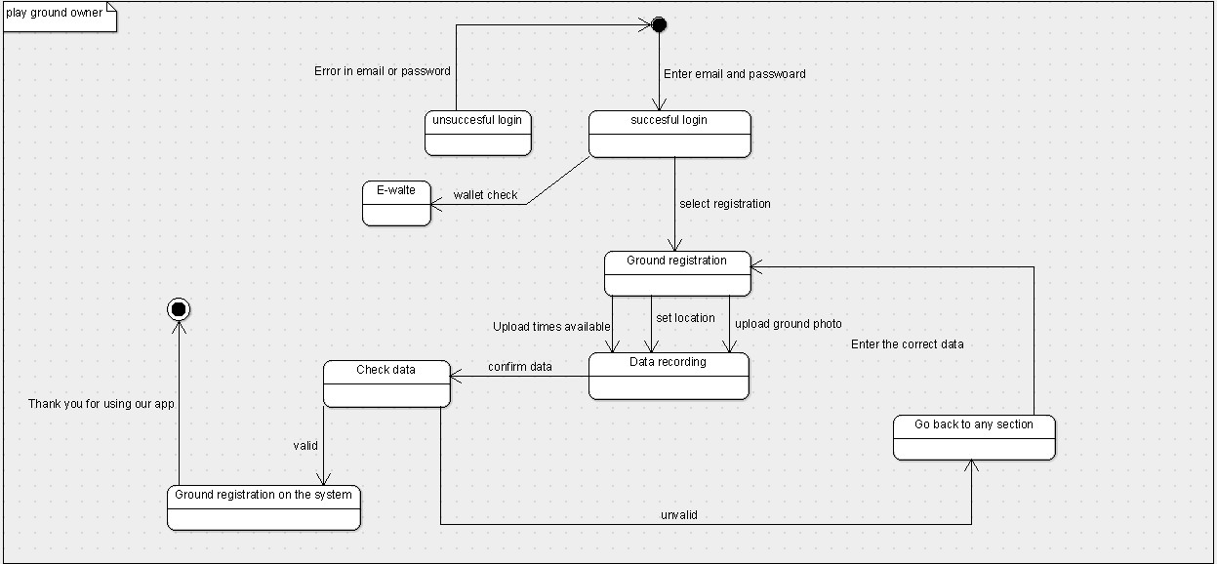

# Tools

* Online diagram.
* Pacestar UML Diagrammer.
* Argo UML.

# Ownership Report

|  |  |
| --- | --- |
| **Item** | **Owners** |
| Aya Allah Abed | Sequence diagrams  Delete playground and Book playground  Table usage for them  playground owner  user  With its Doc  Github |
| Omer Khaled Mohamed | Class diagram  description table  player  playground  administrator  with its Doc  main |
| Abdelrahman Mohamed Saad Abdu | Sequence diagrams  Registration  Registration playground  Table usage for them  State diagram  E-Wallet  with its Doc |